Assignment 2

Part A

* echo command used to print the whatever we write

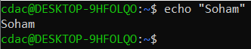

* in shell programming we can store the value at variable which can be integer, string, float etc



And this shell file we can using “bash” command



* touch file. txt : - this command is used to create new file
* 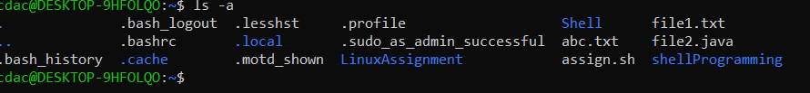ls -a :- it will show all the files including hidden files in current directory
* rm file.txt :- this ‘rm’ command will remove the mentioned file
* cp file1.txt file2.txt : this ‘cp’ commend copies the content of file1 to new file “file2”
* mv file.txt /path/to/directory/ : this ‘mv’ command is used to move the file to particular directory using path
* chmod 755 script.sh : will give READ WRITE and EXECUTE permissions to the owner of file
* “grep” Command is used to find a particular line with provided key word
* Kill PID is command which requires the process ID (PID) to terminate the process
* mkdir mydir && cd mydir && touch file.txt && echo "Hello, World!" > file.txt && cat file.txt

The above set of command finally prints the content of file.txt file

Steps :

1. mkdir command creates the directory mydir
2. && is executes the next command as previous command is true
3. Enters the directory using command ‘cd’
4. Creates the text file named as file using touch command
5. Again logical and is used to move further
6. And using echo command prints the hello world output
7. This hello world output is input of next command
8. Then this hello world is stored in file.txt
9. Displaying the content of file.txt using cat command



* ls -l | grep ".txt" :- this command will show the permissions of all text files in current directory
* cat file1.txt file2.txt | sort | uniq : this command will concatenate the file1.txt and file2.txt and due to unique command it will print unique data
* ls -l | grep "^d" : this command will show all the directories with their permissions
* grep -r "pattern" /path/to/directory/ : this command will print all the lines which contains “pattern” word in all txt files present in desired directory
* cat file1.txt file2.txt | sort | uniq –d : it will display the duplicate(similar) lines in both file
* chmod 644 file.txt : read write permission to owner and read only permission to other
* cp -r source_directory destination_directory: this will copy all the files from one directory to destination directory
* find /path/to/search -name "*.txt" : this will find all the txt file in required directory
* chmod u+x file.txt : it will give user to execute permission for file.txt
* echo $PATH : this command will print the value stored at variable PATH ‘$’ symbol represents value of .

Part B

1. True : ls is command to list the all files and directories present in current directory
2. True
3. False : cp is used to copy the files
4. True
5. True
6. True
7. True
8. True

**Identify the Incorrect Commands**

1. chmodx is used to change file permissions.

**chmod** is the correct command

1. cpy is used to copy files and directories.

**cp** is used to copy files and directories

1. mkfile is used to create a new file.

**touch or nano** is used to create new file

and **mkdir** is used to create directories

1. catx is used to concatenate files.

**cat** is used to concatenate the files

1. rn is used to rename files.

**mv** is used to rename the file by moving the data of one file to another file

Part C

Answer 1: - echo "Hello, World!"

Answer 2: -

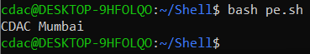

Answer 3: -

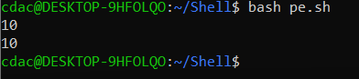

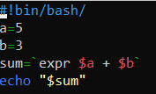Answer 4: -

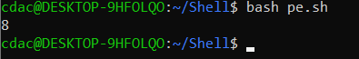

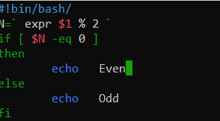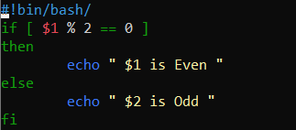Answer 5: -

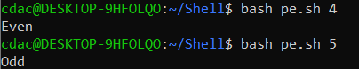

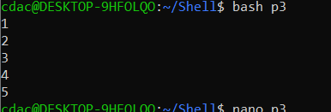

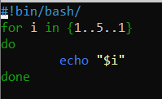Answer 6: -

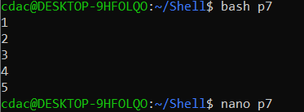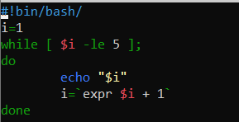Answer 7: -

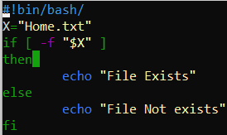Answer 8: -

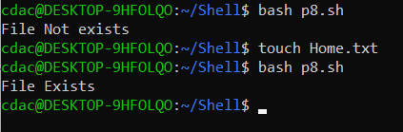

Answer 9: - 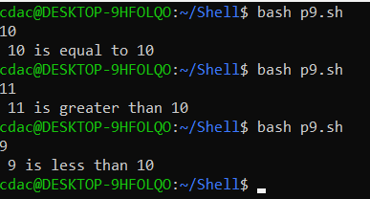

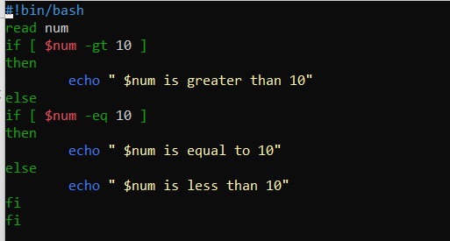

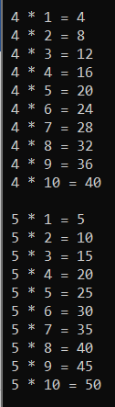Answer 10: -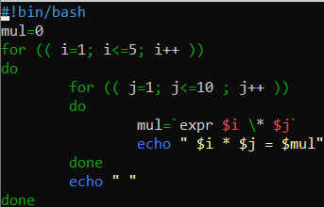

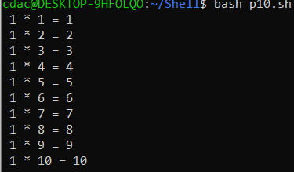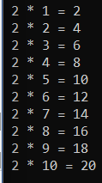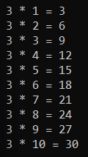

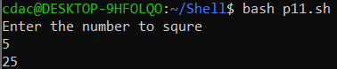Answer 11: -